[INSERT WORK UNIT NAME]

Bloodborne Pathogens Site-Specific Exposure Control Plan
This is a supplement to the UW Core Bloodborne Pathogens Exposure Control Plan (ECP).

OVERVIEW

This site-specific exposure control plan outlines the practices and controls used to mitigate risks for occupational exposure to bloodborne pathogens (BBP) and other potentially infectious materials (OPIM).
Prepared by: | Date:
Phone: | Email:
Principal investigator (PI) or supervisor: | Department/Organization:
Locations that this plan covers (building/room): | Where plan can be accessed:

TRAINING AND DOCUMENTATION
Specify name and role of person responsible for the following: |  | Name, Role

Ensure and document that personnel covered by this plan complete EH&S BBP training prior to being assigned work with potential for exposure to BBP/OPIM and every 12 months thereafter.

Ensure and document that personnel have submitted the electronic Hepatitis B Vaccine form within 10 working days of initial assignment and prior to being assigned work with potential for exposure to BBP/OPIM. The Hepatitis B Vaccine Form can be completed and submitted via EH&S BBP Training.

Ensure and document that personnel receive training on this site-specific plan, the UW Core Exposure Control Plan, and required work practices prior to being assigned work with potential for exposure to BBP/OPIM and every 12 months thereafter.

Review and resolve exposure incidents and near misses.

Implement recommendations for changes to this plan.

Review this plan at least annually and update if needed.

PERSONNEL FEEDBACK

How is the work group involved in identifying and evaluating changes to improve work practices? How can personnel provide feedback on this plan? (Select all that apply and describe how this occurs.)
☐ Employee feedback (specify how to give feedback):
☐ Staff or laboratory meetings (specify meeting and frequency):
☐ Safety committee activities (specify committee and frequency):
☐ Exposure incident investigation (supervisor must add information to the OARS report including root cause and corrective actions):
☐ Other (specify):

PERSONNEL
List personnel and/or job titles who have potential occupational exposure to human blood or OPIM and who require training on this exposure control plan:

TASKS WITH POTENTIAL EXPOSURE AND REQUIRED SAFETY MEASURES
Procedure/task with potential exposure to BBP | Personal protective equipment (PPE) required | Engineering controls or equipment required
Procedure/task 1: | Face Protection:  ☐ Face shield ☐ Surgical mask  ☐ Other:  Eye Protection:  ☐ Safety glasses ☐ Goggles  ☐ Other:  Gloves:  ☐ Nitrile gloves (single layer)  ☐ Nitrile gloves (double layer)  ☐ Other:  Skin/Clothing:  ☐ Apron ☐ Coveralls ☐ Gown  ☐ Lab coat ☐ Other:  Respiratory protection:  ☐ CPR mask or barrier ☐ N95  ☐ Respirator (specify type): | ☐ Sharps waste container  ☐ Tongs, forceps, broom/dustpan for handling broken glass/sharps  ☐ Work inside biosafety cabinet  ☐ Splash guard on benchtop  ☐ Centrifuge with aerosol containment  ☐ Plastic substitutions for glass:  ☐ Needles with safety features:  ☐ Needle-less systems:  ☐ Other:
Procedure/task 2: | Face Protection:  ☐ Face shield ☐ Surgical mask  ☐ Other:  Eye Protection:  ☐ Safety glasses ☐ Goggles  ☐ Other:  Gloves:  ☐ Nitrile gloves (single layer)  ☐ Nitrile gloves (double layer)  ☐ Other:  Skin/Clothing:  ☐ Apron ☐ Coveralls ☐ Gown  ☐ Lab coat ☐ Other:  Respiratory protection:  ☐ CPR mask or barrier ☐ N95  ☐ Respirator (specify type): | ☐ Sharps waste container  ☐ Tongs, forceps, broom/dustpan for handling broken glass/sharps  ☐ Work inside biosafety cabinet  ☐ Splash guard on benchtop  ☐ Centrifuge with aerosol containment  ☐ Plastic substitutions for glass:  ☐ Needles with safety features:  ☐ Needle-less systems:  ☐ Other:
Procedure/task 3: | Face Protection:  ☐ Face shield ☐ Surgical mask  ☐ Other:  Eye Protection:  ☐ Safety glasses ☐ Goggles  ☐ Other:  Gloves:  ☐ Nitrile gloves (single layer)  ☐ Nitrile gloves (double layer)  ☐ Other:  Skin/Clothing:  ☐ Apron ☐ Coveralls ☐ Gown  ☐ Lab coat ☐ Other:  Respiratory protection:  ☐ CPR mask or barrier ☐ N95  ☐ Respirator (specify type): | ☐ Sharps waste container  ☐ Tongs, forceps, broom/dustpan for handling broken glass/sharps  ☐ Work inside biosafety cabinet  ☐ Splash guard on benchtop  ☐ Centrifuge with aerosol containment  ☐ Plastic substitutions for glass:  ☐ Needles with safety features:  ☐ Needle-less systems:  ☐ Other:
Procedure/task 4: | Face Protection:  ☐ Face shield ☐ Surgical mask  ☐ Other:  Eye Protection:  ☐ Safety glasses ☐ Goggles  ☐ Other:  Gloves:  ☐ Nitrile gloves (single layer)  ☐ Nitrile gloves (double layer)  ☐ Other:  Skin/Clothing:  ☐ Apron ☐ Coveralls ☐ Gown  ☐ Lab coat ☐ Other:  Respiratory protection:  ☐ CPR mask or barrier ☐ N95  ☐ Respirator (specify type): | ☐ Sharps waste container  ☐ Tongs, forceps, broom/dustpan for handling broken glass/sharps  ☐ Work inside biosafety cabinet  ☐ Splash guard on benchtop  ☐ Centrifuge with aerosol containment  ☐ Plastic substitutions for glass:  ☐ Needles with safety features:  ☐ Needle-less systems:  ☐ Other:
Procedure/task 5: | Face Protection:  ☐ Face shield ☐ Surgical mask  ☐ Other:  Eye Protection:  ☐ Safety glasses ☐ Goggles  ☐ Other:  Gloves:  ☐ Nitrile gloves (single layer)  ☐ Nitrile gloves (double layer)  ☐ Other:  Skin/Clothing:  ☐ Apron ☐ Coveralls ☐ Gown  ☐ Lab coat ☐ Other:  Respiratory protection:  ☐ CPR mask or barrier ☐ N95  ☐ Respirator (specify type): | ☐ Sharps waste container  ☐ Tongs, forceps, broom/dustpan for handling broken glass/sharps  ☐ Work inside biosafety cabinet  ☐ Splash guard on benchtop  ☐ Centrifuge with aerosol containment  ☐ Plastic substitutions for glass:  ☐ Needles with safety features:  ☐ Needle-less systems:  ☐ Other:

PERSONAL PROTECTIVE EQUIPMENT (PPE)
Personnel are trained on the following regarding use of PPE:
☐ Required PPE and practices for tasks with potential exposure to blood or OPIM.
- Location of PPE and clothing:
☐ Handling and disposal of soiled, contaminated, or damaged PPE.
☐ PPE doffing procedures to minimize risk of cross contamination.
- List the order in which PPE is removed:
☐ Procedures for containing and laundering reusable PPE or clothing:
☐ Frequency of laundry for reusable PPE or clothing:
☐ Person(s) responsible for laundry:

WORK PRACTICE CONTROLS
The following work practice controls are used to minimize exposure to blood or OPIM in addition to universal precautions:
☐ No eating, drinking, or applying cosmetics in work areas with blood and/or OPIM.
☐ Hands are washed when gloves are removed, before leaving the work area, and whenever soiled or contaminated.
☐ Minimize splashing, spraying, splattering, and generation of droplets or aerosols of blood or OPIM.
☐ Biohazard warning labels are affixed to containers used to store or transport blood, OPIM, or BBP waste.
☐ Sealed secondary, non-breakable, leakproof, labeled containers are used to transport specimens of blood, OPIM, or contaminated items.
☐ Follow standard operating procedures (SOPs). List site-specific SOPs:
☐ List other work practice controls:

SHARPS SAFETY
Review the Work Safely with Sharps Focus Sheet and Sharps Safety webpage if using sharps.
Describe sharps procedures:

Sharps safety training for personnel includes:
☐ Safe handling and disposal of sharps:
☐ Practice sharps use with harmless materials before using higher risk hazardous materials:
☐ Follow standard operating procedures for use of safety-engineered sharps devices (list devices, such as needleless tubing systems, self-sheathing, or retractable needle-syringes, etc.):
☐ Sharps alternatives (i.e., blunt tip needles, plastic Pasteur pipets):

Reusable sharps safety practices:
☐ Reusable sharps are stored in secure, labeled containers when not in use. Describe storage method:
☐ Contaminated reusable sharps are placed into appropriate containers for decontamination immediately or as soon as possible after use. Describe decontamination method:
☐ Reusable sharps containers are not opened, emptied, or cleaned in any manner that would expose personnel to contaminated sharps.
☐ Other reusable sharps safety practices:

Disposable sharps safety practices:
☐ Red, hard sided, leakproof sharps waste containers with a biohazard symbol are kept near the workspace.
☐ Disposable sharps are placed in a sharps waste container immediately after use.
☐ Sharps containers are inspected, maintained, and replaced to prevent overfilling (no more than 2/3 full).
☐ Person(s) responsible for disposal of sharps waste containers:
☐ Specify method of decontamination and disposal for sharps waste containers. If containers are sent for autoclaving, include location, and if shipped off-site, include storage location:

DECONTAMINATION AND WASTE DISPOSAL
For routine cleaning, how are surfaces and equipment decontaminated? Include the disinfectant and contact time. (Reference EPA’s Registered Antimicrobial Products Effective Against Bloodborne Pathogens.)

For spills, how are surfaces and equipment decontaminated? Include the disinfectant, contact time, and any waste packaging procedures. Reference the Spill Response Poster.

What is the procedure for packaging, decontamination, and disposal of BBP waste? List location where waste is autoclaved or stored for off-site shipping or pick-up:

RECORDKEEPING
Refer to the UW Core BBP Exposure Control Plan for more information about:
      - Post exposure medical follow-up and evaluations.
- Employee medical records.
Use the Training and Documentation Log at the end of this plan to document training and Hepatitis B Vaccine Form submission dates.

PI/RESPONSIBLE PERSON SIGNATURE AND DATE OF MOST CURRENT ECP REVIEW
Name | Signature |  | Date

REGULATIONS AND RESOURCES
- EH&S Bloodborne Pathogens (BBP) webpage  - WA State BBP regulations (WAC 296-823)  - EH&S BBP online training  - UW Core Exposure Control Plan  - UW Biosafety Manual |  | - UW Employee Health Centers  - Hepatitis B Vaccine Form  - EH&S Work Safely with Sharps  - EH&S Sharp Safety webpage  - EH&S PPE webpage
CONTACT
Call 206-221-7770 for questions about the BBP program or BBP training.

EMERGENCY PROCEDURES
Call 9-1-1 for any life-threatening emergency. Otherwise, follow the steps on the Exposure Response Poster (view the most recent version on the EH&S website). Report incidents via the Online Accident Reporting System (OARS):
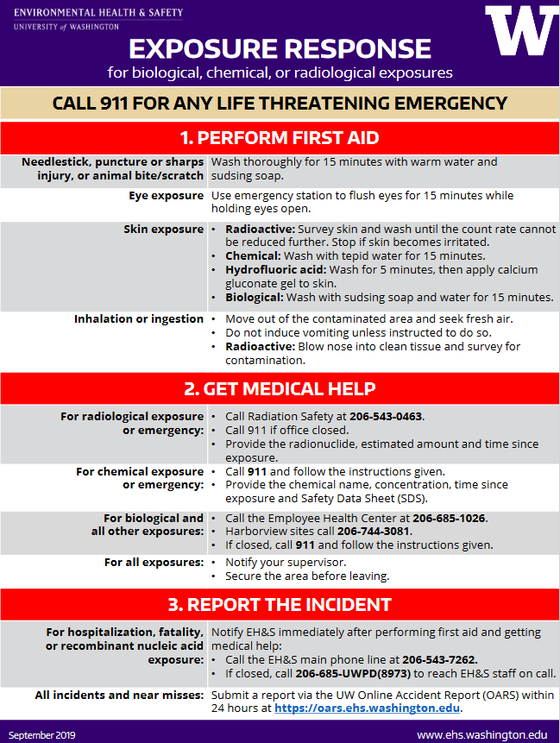

DOCUMENTATION OF TRAINING ON SITE-SPECIFIC EXPOSURE CONTROL PLAN, BLOODBORNE PATHOGENS (BBP) TRAINING, AND HEPATITIS B VACCINE FORM

By signing below, I indicate that I have reviewed and understand this Site-Specific Exposure Control Plan (“Plan”) and have been given a chance to ask questions. I will adhere to the practices outlined in this site-specific BBP Exposure Control Plan and BBP Training.
Name and Signature | Date of training on this Plan. Indicate if initial or annual. | Date(s) of Initial and Annual EH&S BBP training. | Date Hepatitis B Vaccine form submitted.

